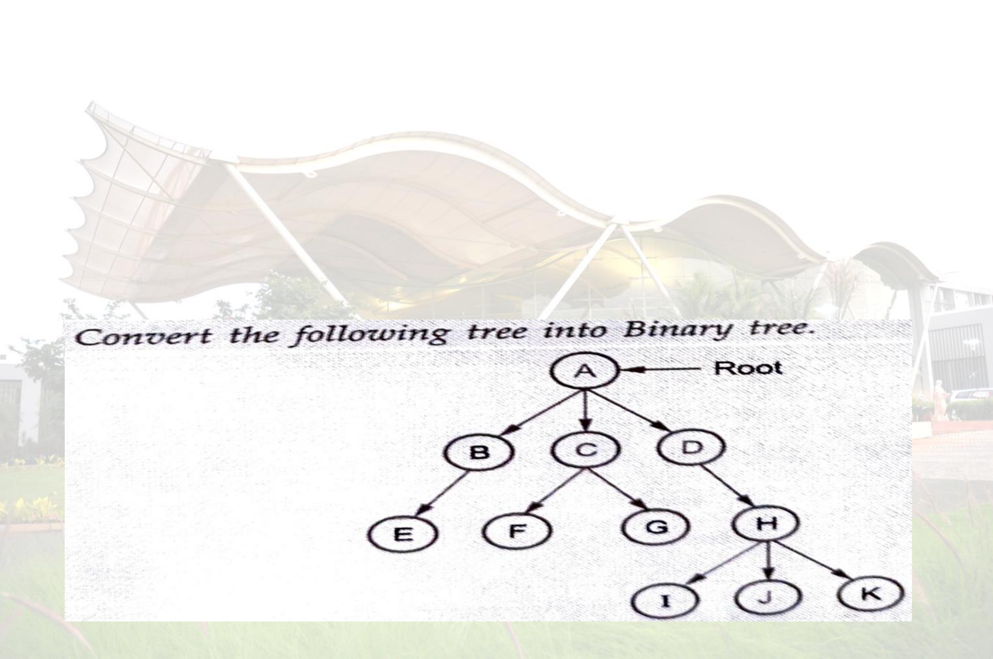
SE COMPUTER (2024 PATTERN) DATA STRUCTURE
Mumbai Education Trust’s
INSTITUTE OF ENGINEERING, NASHIK.
COMPUTER ENGINEERING DEPARTMENT
Subject : DS | ASSIGNMENT NO – 05 | Unit - IV
1. Define Basic Terminologies of Trees with example and Explain Binary tree with its Types(examples).
2. Define Basic Terminologies of Graph with example and Explain Types of graph.
3. Explain Tree Traversal(all traversal) with it recursive algorithms and example. 4. Write an algorithm for non recursive post order traversal of binary tree.
5. Describe and Write an algorithm to delete a node from binary search tree.
6. Write pseudo code DFS & BFS traversal of binary search tree.
7. Write an algorithm for depth first traversal & Breadth First Traversal of a graph. 8. With suitable example , Explain step for conversion of a general tree into binary tree.
Note : Consider root as A
9. Explain the Binary Search Tree in details with following example.
Contruct Binary Search Tree(BST) for the following :
a)J, R, D, G, T, E, M, H, P, A, F, Q
b)MAR, MAY, NOV. AUG, APR, JAN, DEC, JUL, FEB, JUN, OCT, SEPT
10. The following numbers are inserted into an empty binary search tree in the given order : G, C, B, A , D, E, F, I, H. Construct tree step by step. Represent the constructed tree using static memory allocation.
Prepared BY : Prof. Gharu Anand

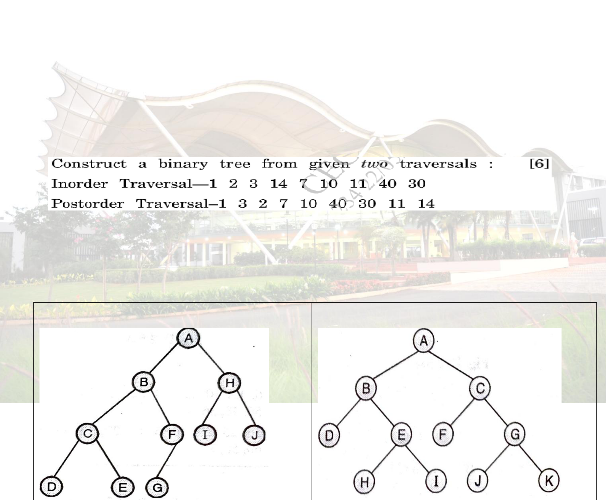
SE COMPUTER (2024 PATTERN) DATA STRUCTURE
11.
a) From the given traversals construct the binary tree :
Inorder : EICFJBGDKHL postorder : IEJFCGKLHDB
Draw the binary tree and write preorder traversal.
b) From the given traversals construct the binary tree.
Pre-order : G, B, Q, A, C, K, F, P, D, E, R, H
In-order : Q, B, K, C, F, A, G, P, E, D, H, R
c)
Generate binary tree for the following pre-order and in-order traversals : Pre-order : E A C K F H D B G
In-order : F A E K C D H G B
d) Construct a binary tree from its given preorder traversal PQSXYTRUV and postorder traversal XYSTQUVRP and apply inorder traversal to it.
e)
.
12. Solve following Tree traversal examples. Perform inorder , preorder and postorder
traversal of binary tree.
1. | 2.

Prepared BY : Prof. Gharu Anand

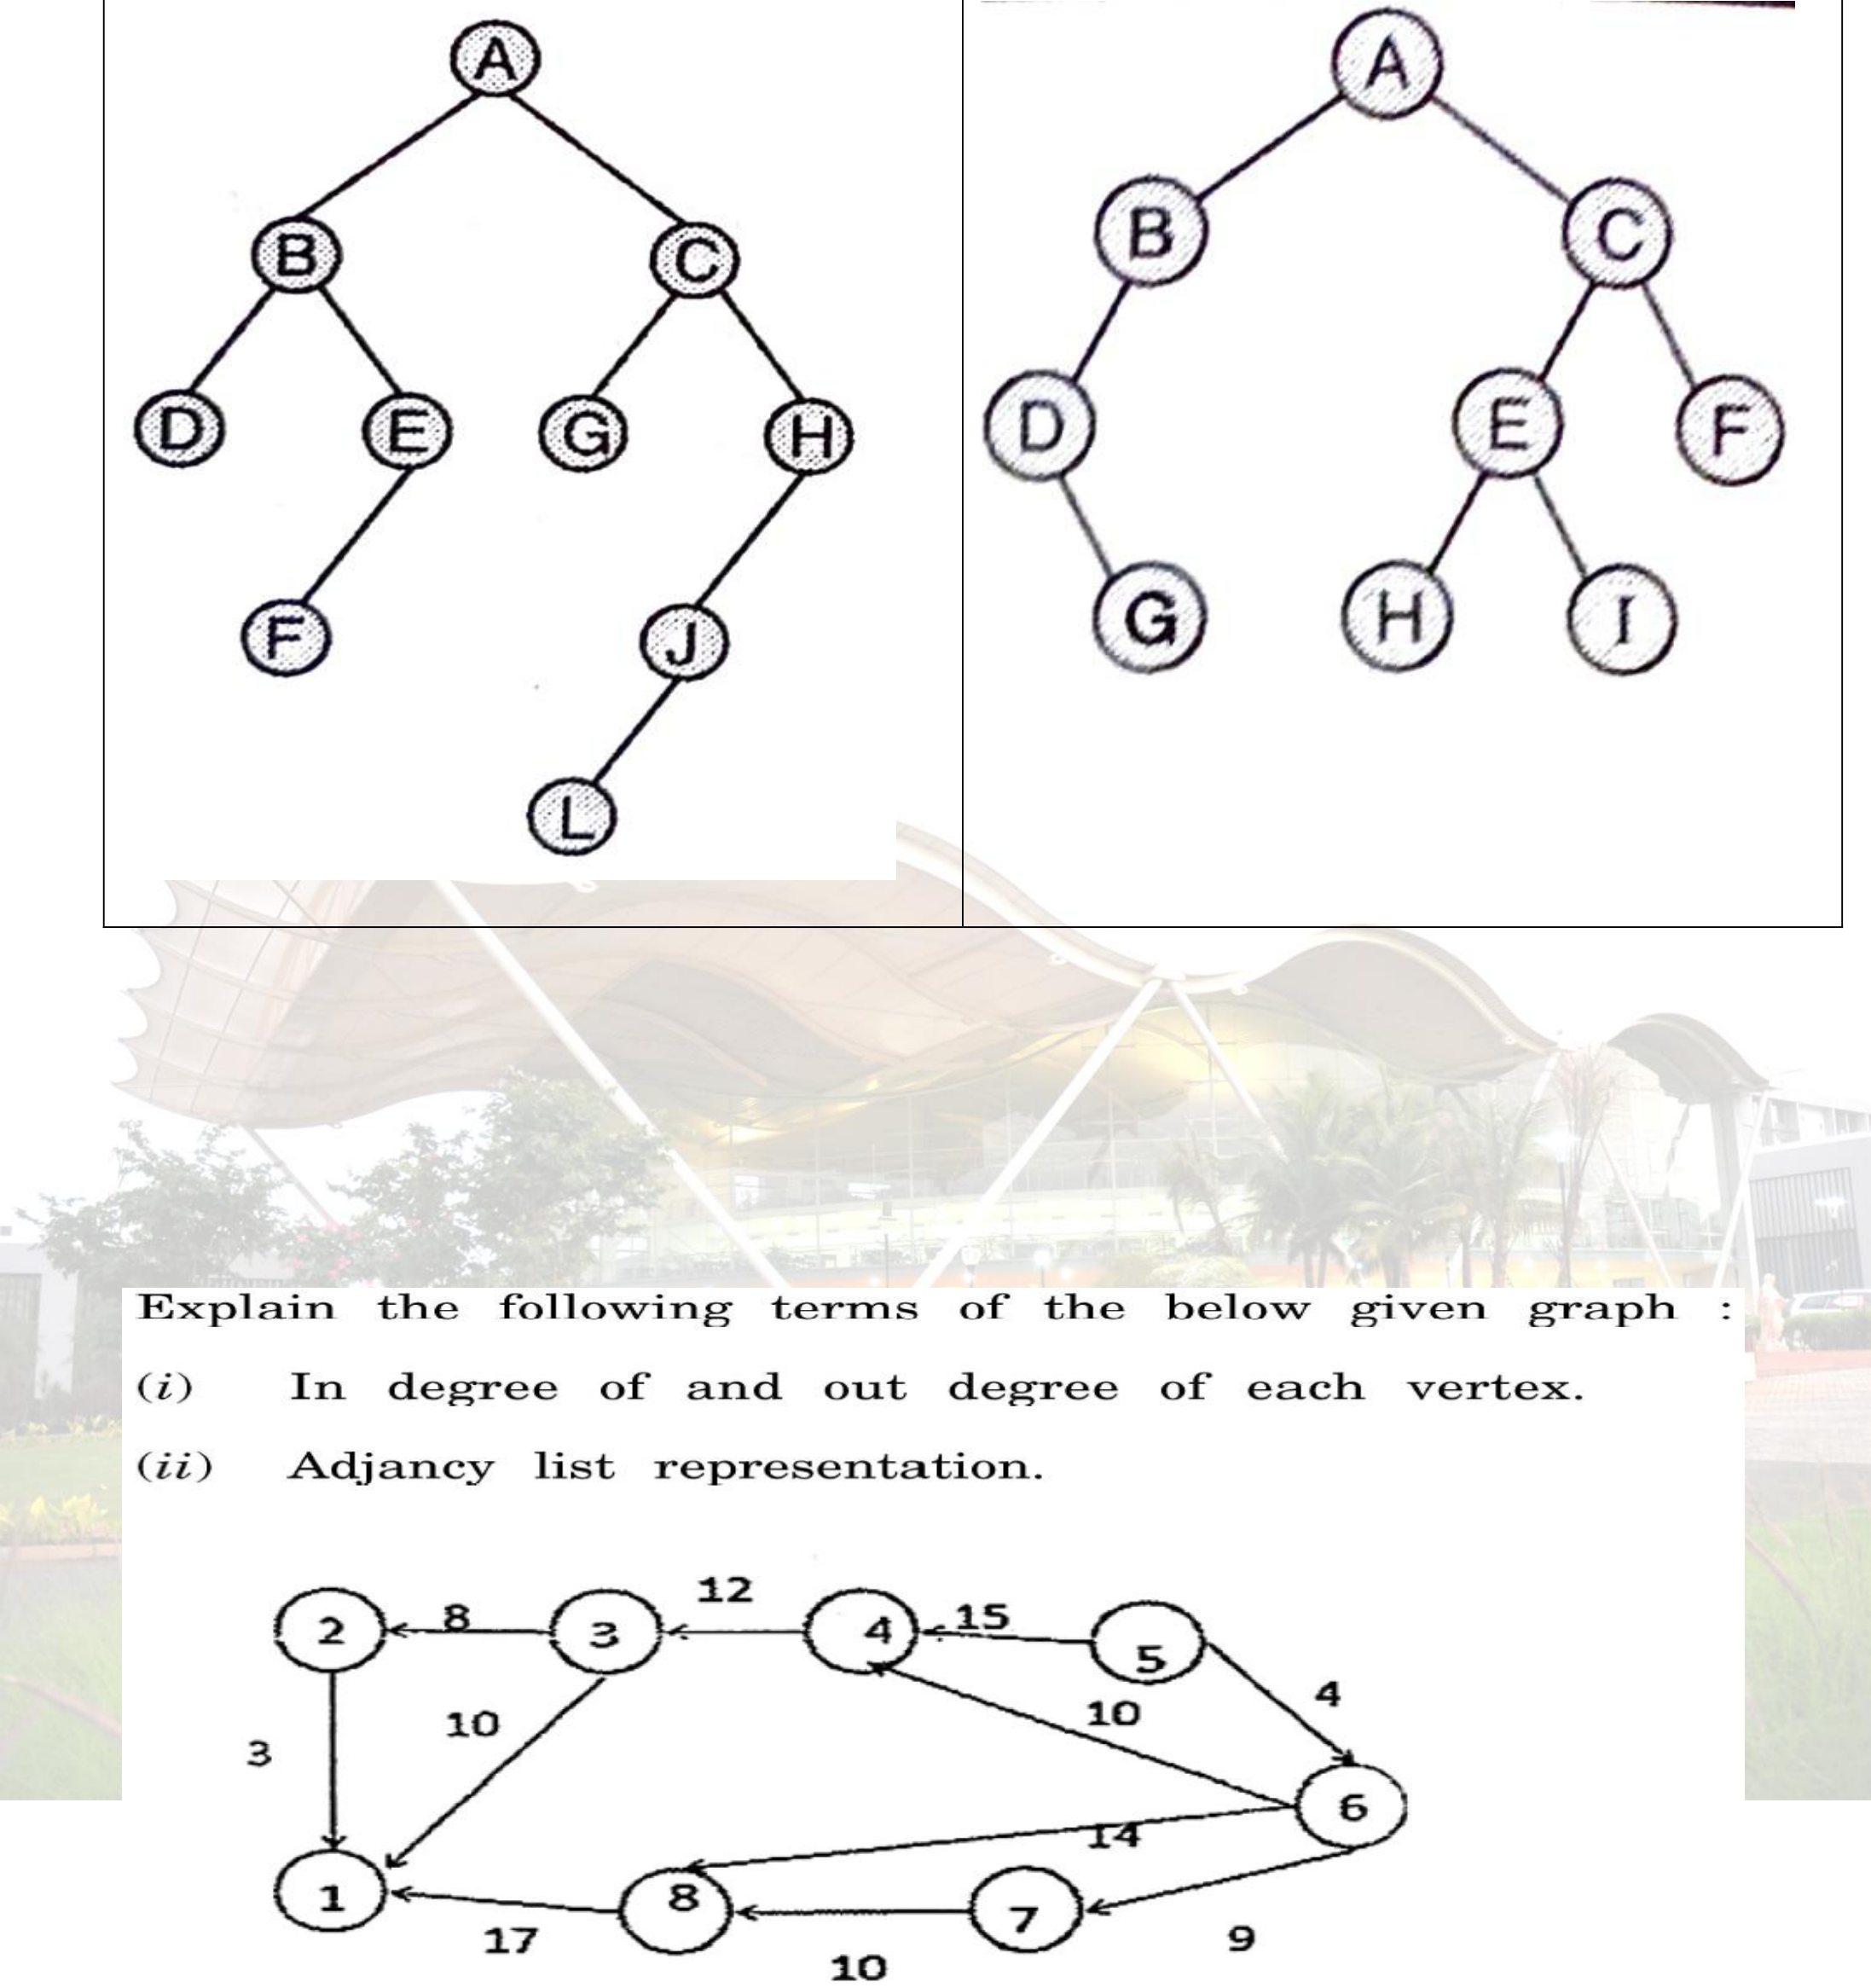
SE COMPUTER (2024 PATTERN) DATA STRUCTURE
 |  | 3. | 4.
 | 1  1  15 | 3. Draw any directed graph with mi adjacency matrix, adjacency list and inve 4.  . Define DFS and BFS for a graph. with starting vertex as 1. | nimum 6 nodes and represent graph usin rse adjacency list.  Show BFS and DFS for the following grap | g  h
Prepared BY : Prof. Gharu Anand

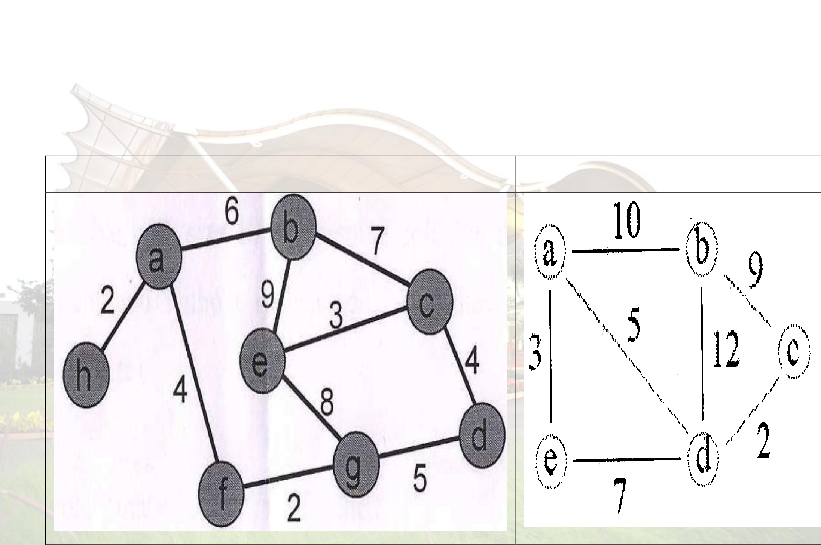
SE COMPUTER (2024 PATTERN) DATA STRUCTURE
 | 16 | . Write Kruskal’s algorithm for minimum s  example.Find the MST for the graph given using  the Step. | panning trees and explain with Kruskals Algorithm and show all
 |  | Example 1 : | Example 2 :
 | 17 | . Construct the minimum spanning tree (MST)  Algorithm staring from vertex 6. | for the given graph using Prim’s
Prepared BY : Prof. Gharu Anand

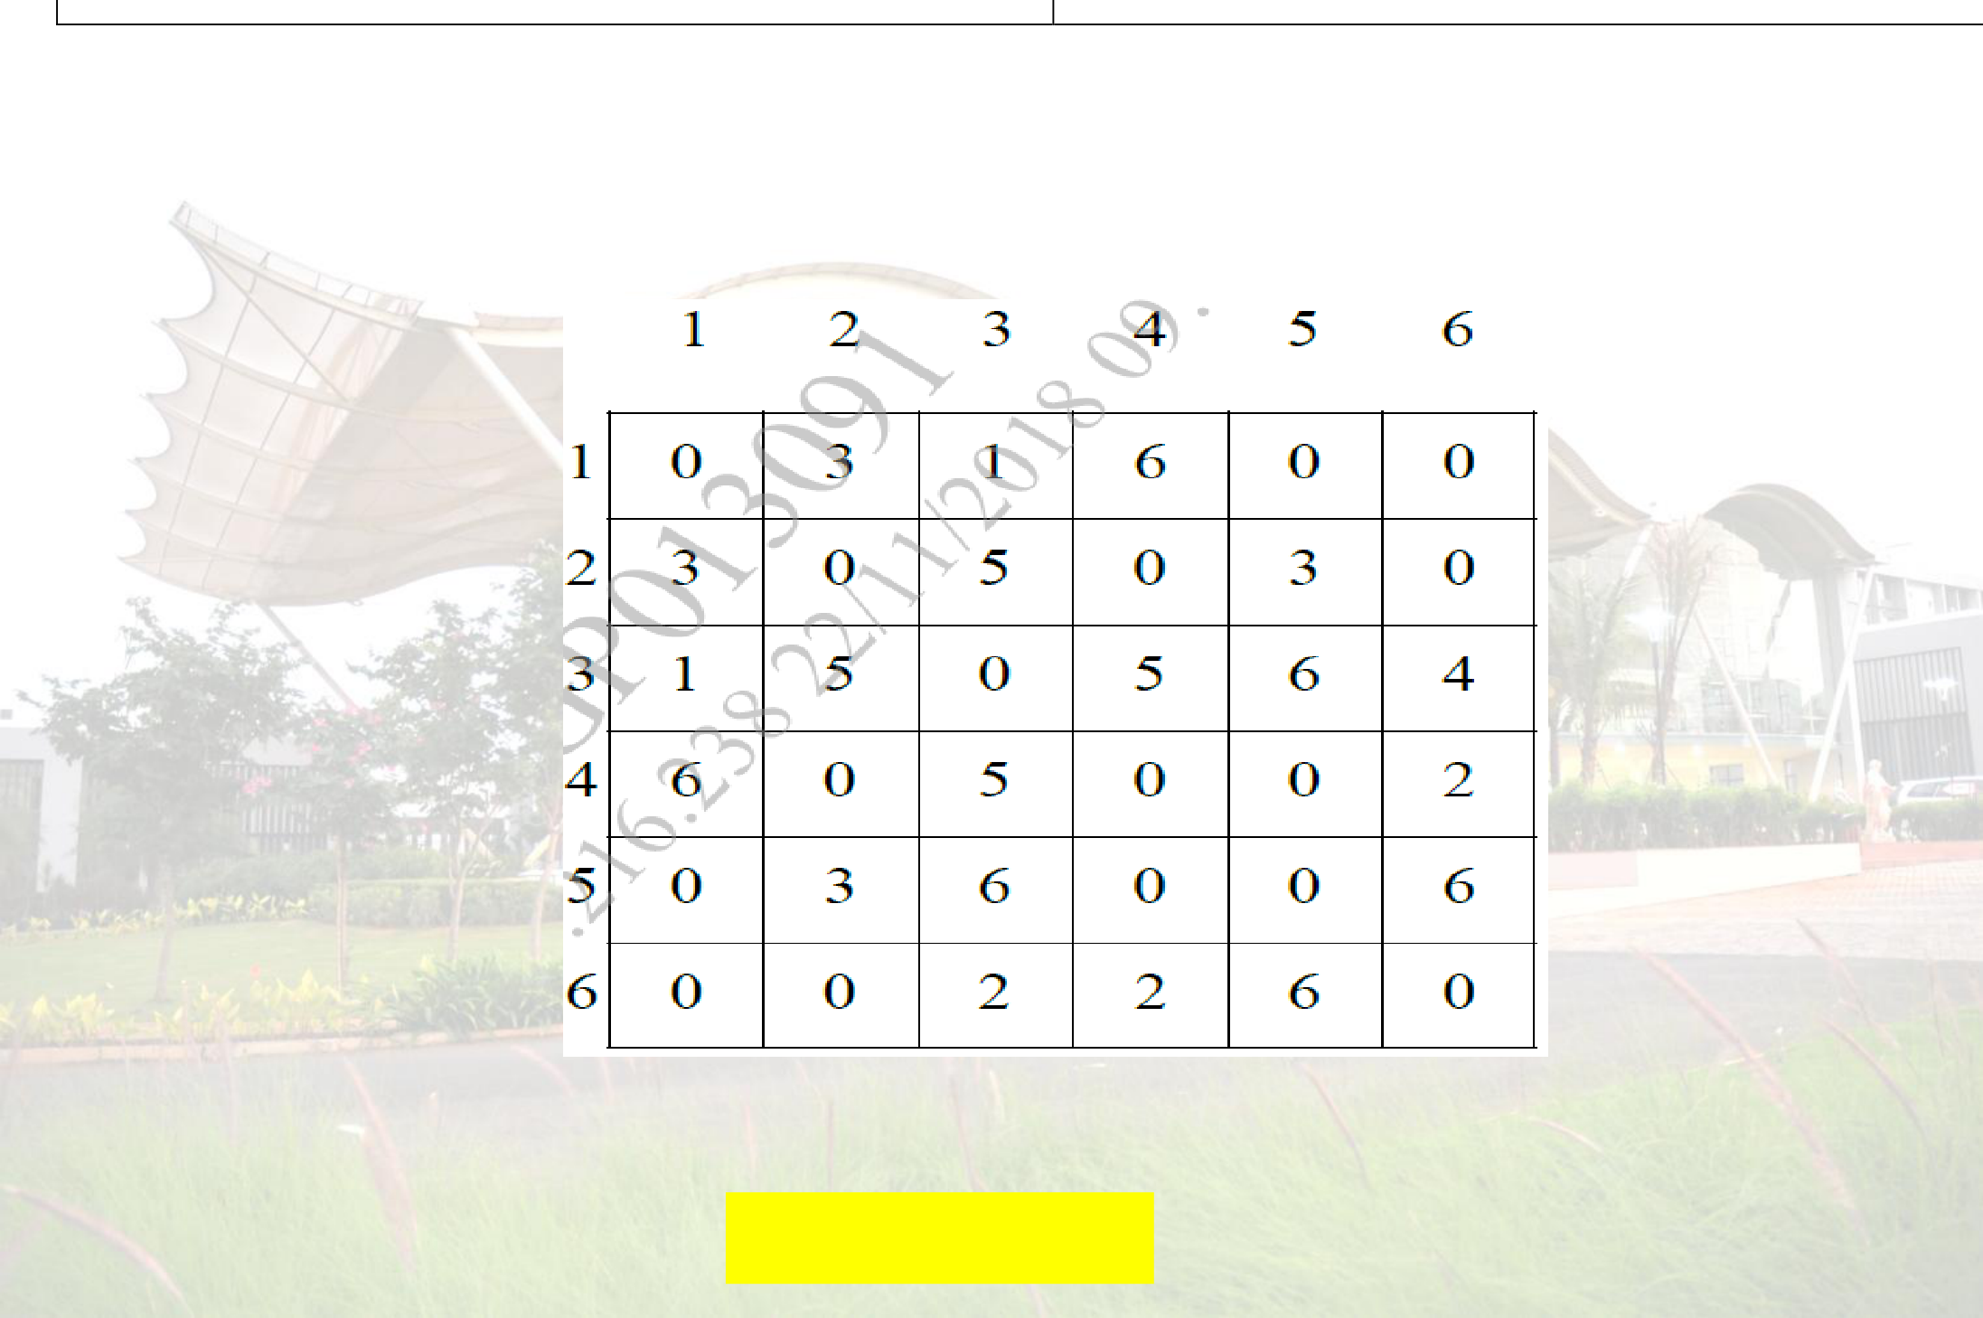
SE COMPUTER (2024 PATTERN) DATA STRUCTURE
 |  | 18. Construct MST from the given data | using Prims Algorithms.
 |  | Example 1: | Example 2:
 |  |  | 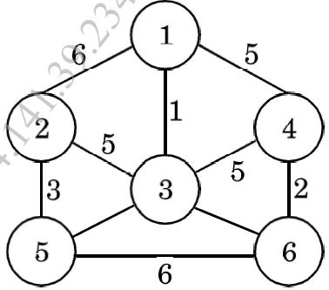
 | ** | 19. Consider the graph represented by t  And find minimum spanning tree of this gr  **************** Best of Lu | he following adjacency matrix : aph using Prim’s algorithm.  ck *******************
Prepared BY : Prof. Gharu Anand

 Study material provided by:Vishwajeet Londhe

 Telegram Channel
(for all engineering Resources)
 | 
https://whatsapp.com/channel/ 0029ValjFriICVfpcV9HFc3b



